Application Server and Web Server

01. Install nginx and run nginx on port number 81.
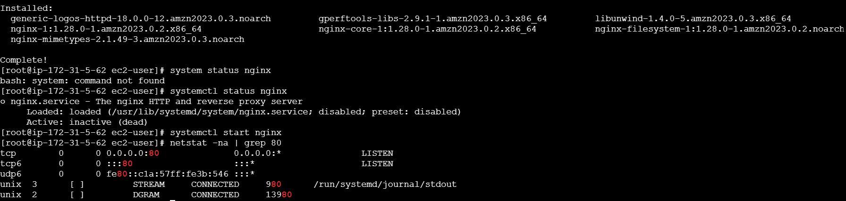
Steps:
# yum install nginx
# systemctl start nginx
# systemctl status nginx
#netstat -na | grep 80
Nginx is installed.

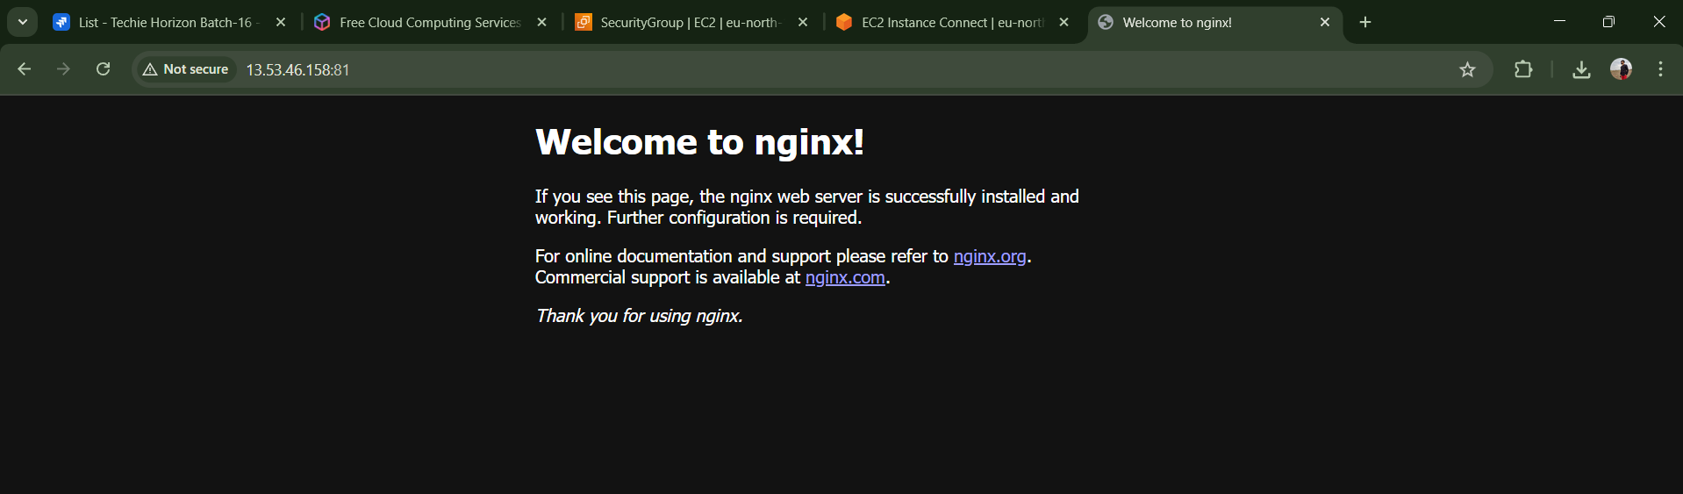
Steps:
Successfully running nginx on port no.81
#Deployment location -- /usr/share/nginx/html
#cd /usr/share/nginx/html
# vi index.html
02. Deploy a sample index.html file on nginx.

- 
- Steps:
- # I copied sample static website from browser
- #cd /usr/share/nginx/html
# wget copied link pasted here
# rename to index.html mv filename index.htlm

03. Install Apache and run Apache on port number 82
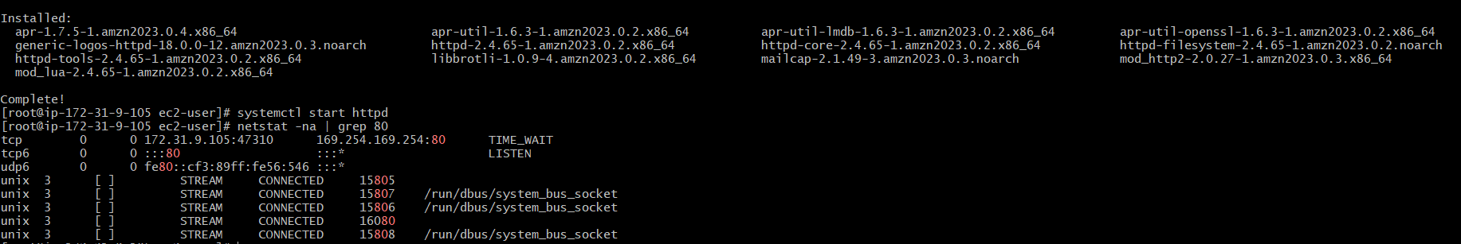
Steps :
#installed apache
yum install httpd
systemctl start httpd
netstat -na | grep 80

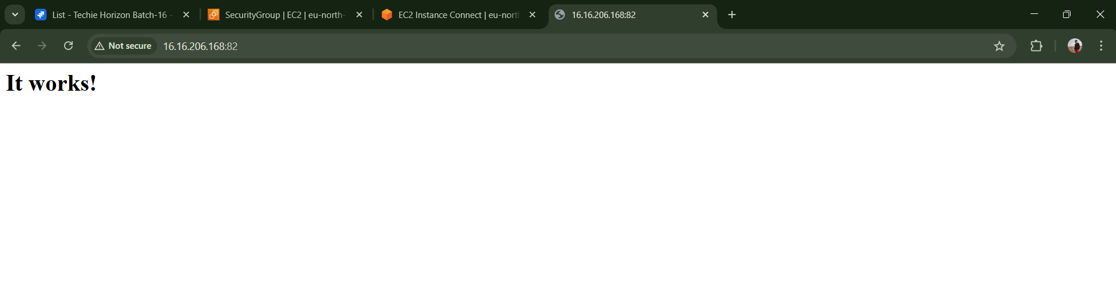
This is with port : 82

04. Deploy a sample index.html file on Apache.

Steps:
I have created one sample file with index.html
By using touch index.html
Then vi index.html
Inserted text : <h1> welcome to techie horizon<h1>
Checked in browser it is running.

05.Install Apache tomcat on port number 8082

06. Deploy a sample app on webapps

07. Create a tomcat.service file for tomcat.

08. Configure HA Proxy server

